Everybody Active Sessions Autumn/Winter 2016
Boccia  Wednesdays  18:30 – 19:30  Westburn Lounge, Westburn Park, Westburn Road, Aberdeen, AB15 9TP  £2.55 per session | Stable & Able  Fridays  11:00 – 12:00  Westburn Lounge, Westburn Park, Westburn Road, Aberdeen, AB15 9TP  £2.55 per session | Football  Fridays  13:30 – 15:00  Sheddocksley Sports Centre, Springhill Road, Aberdeen, AB16 6QJ  £2.55 per session
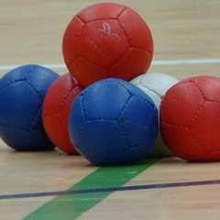 | 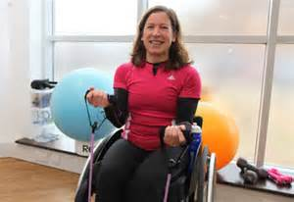 | 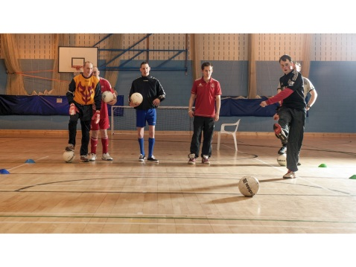
These fun boccia sessions are open to beginners and more experienced players.  Boccia is a seated sport where the aim of the game is to get your balls as close to the jack ball as possible.  Full of fun, skill, tactic and teamwork it’s ideal for everyone.  Sessions run during school term time only. | These classes are aimed at participants with a physical disability which effects strength, co-ordination & balance. Classes include sitting, and where possible standing exercises that are great for maintaining or regaining your Strength and Balance. Exercises can be adapted to suit individual needs. | Fun football sessions led by coaches from AFC Community Trust.  Sessions have a great mix of fun skills and drills and match play.  Support workers and friends are welcome to join in too.  Sessions run during school term time only.
For more information please contact Andrinne on: 01224 047926 or ACraig@sportaberdeen.co.uk

