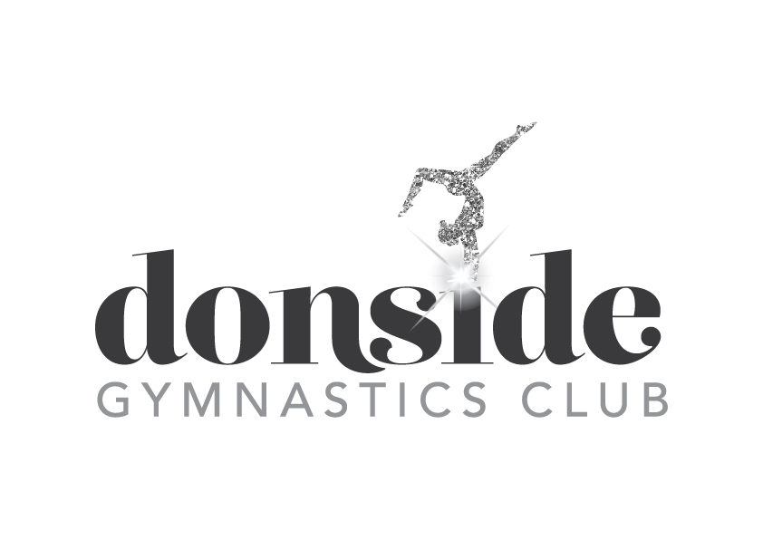

NEW!!
ADVANCED RECREATIONAL CLASS

There will be an advanced recreational class beginning after the new year on a Sunday from 1130 – 1330 the cost will be £11 for the class payable per term.
If you are interested please contact Sandra Simpson on 07867 487682 or
e-mail donsidegymnastics@btinternet.com

